FAMU - FSU COLLEGE OF ENGINEERING

Senior Design Team 310

*Professor:* DR. Hooker & DR. McConomy



Functional Decomposition



*Authors:*

Denis Dineen

Jacob Hutto

Hunter Kramer

Doran McFalls

Nicolas Palmeiro

*Date:*

September 27th, 2019



**Functional Decomposition**

Functional Decomposition is the breakdown of seemingly complex systems or processes into smaller parts. The objective of functional decomposition is to describe the physical action and outcomes of a design, rather than developing specific solutions to the problem. The desired result is to express the lowest levels of action that work in unison to perform the project’s main goals. Our team identified four critical subsystems of our robotic lineman: safety, operation, efficiency, and integration. The safety subsystem attempts to increase the safety of human lineworkers and minimize device damage during field operation. The operation subsystem focuses on the device performing the basic functions of its human counterpart. The efficiency subsystem looks to increase the success level of current linework work and procedures. Lastly, the integration subsystem presents different measures to educate and train future line workers on company-wide standards. While performing the functional decomposition, our team discovered the low level actions overlap into multiple subsystems. The functional hierarchy and cross-reference matrix below display these relationships.

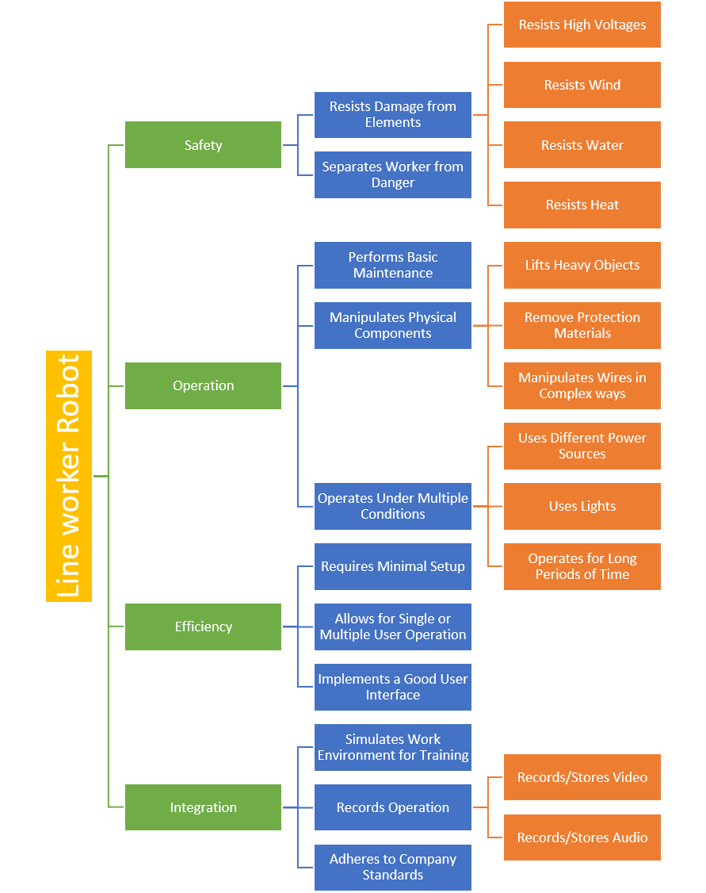

Figure 1: Functional Hierarchy

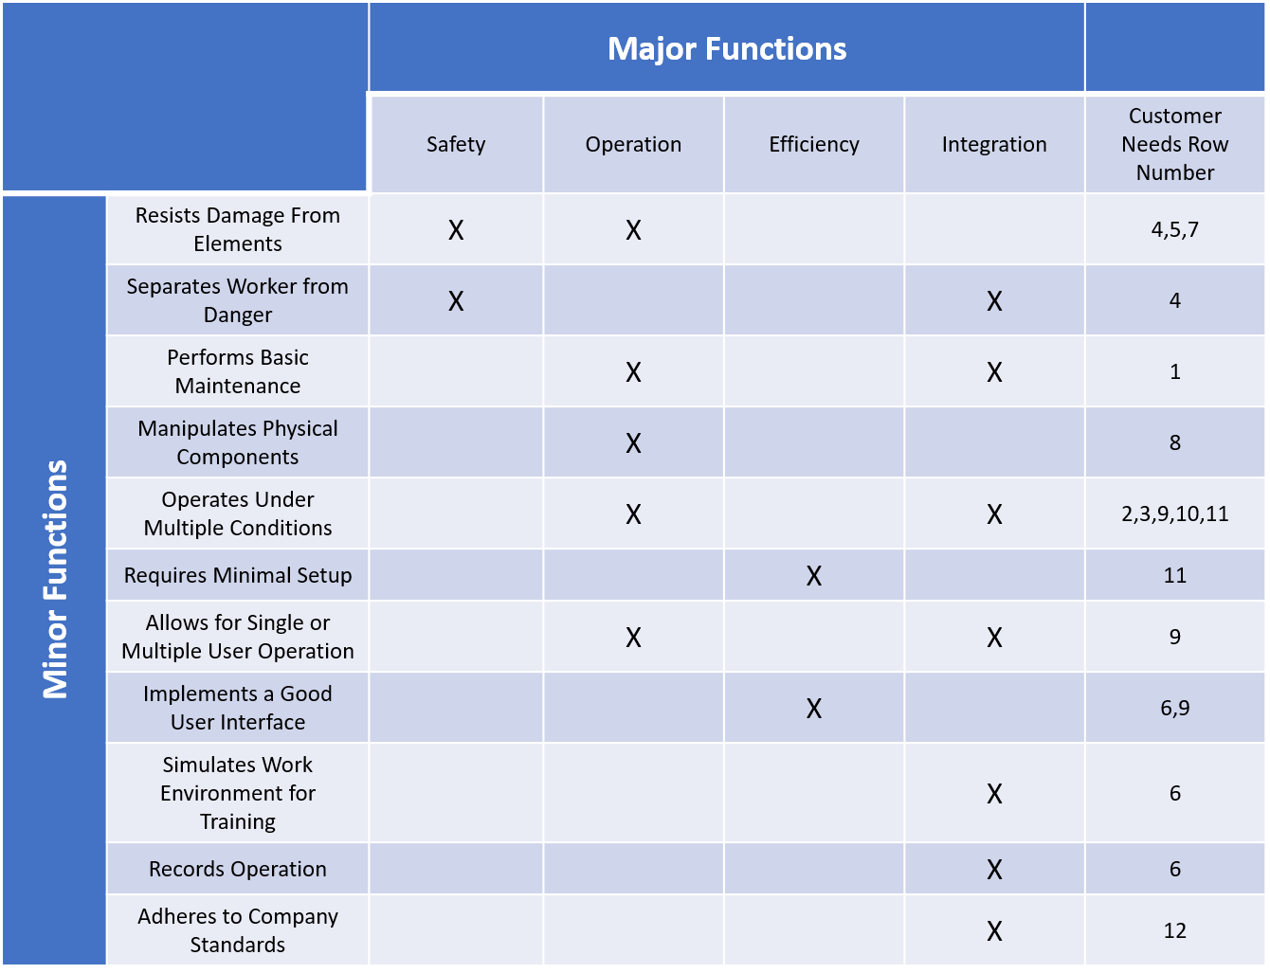

Figure 2: Cross-Reference Matrix